Complete Tutorial on git and linux:

1. Covered all the basic commands
2. Files and directory types
3. Git commit and pushes
4. 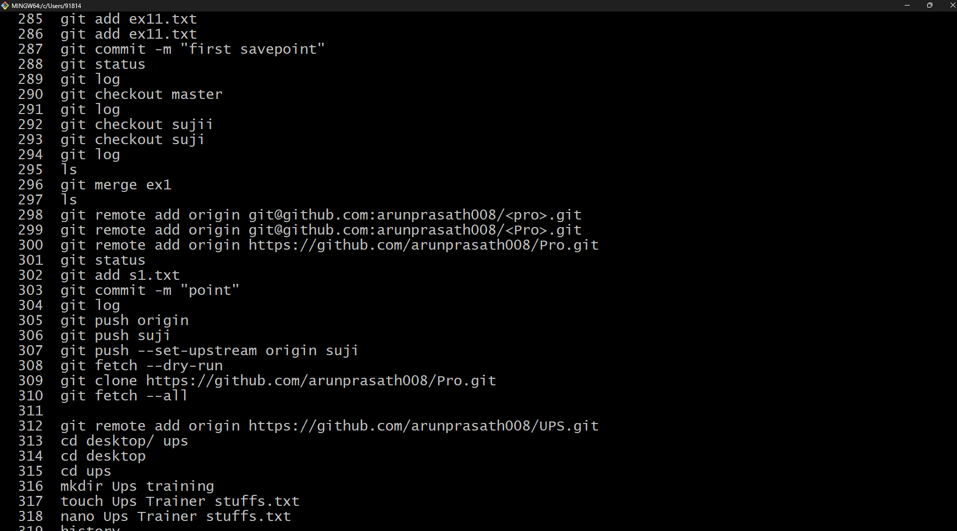Ex:

How to add folders and files in github directly in command line

